



**nterprise TAPS**

* A customized phone service that provides enhanced visual deployment tools and data collection for Cisco VoIP phones.
* Built using Python3.6 and Flask with API integrations into CUCM and Cisco Webex Teams.

1. **Start Page –** Auto-display via IDLE URL in Auto-Registration template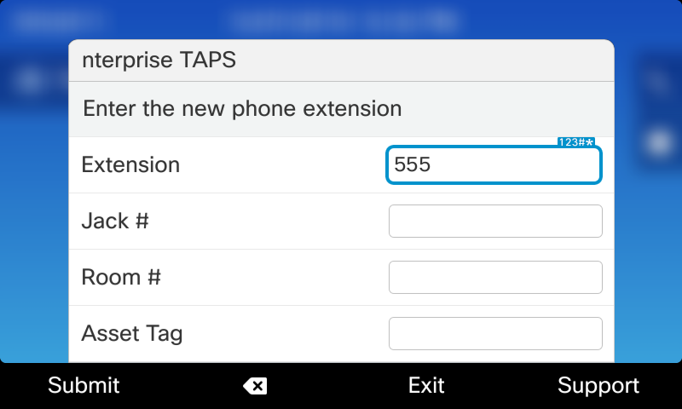
   1. Can preconfigure an extension prefix for long DNs with same starting range
   2. Can have up to 4 custom fields defined for data collection
   3. On any screen there is a configurable Support number so you can quickly call the folks working on the backend for help.
2. **NO MATCHES FOUND**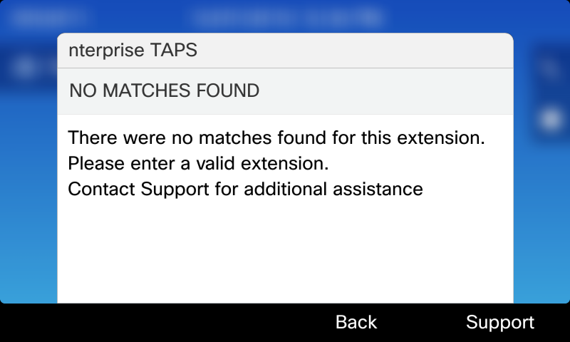
   1. Doing a search, if no matches are found for the extension you will see an error
3. **MODEL MISMATCH**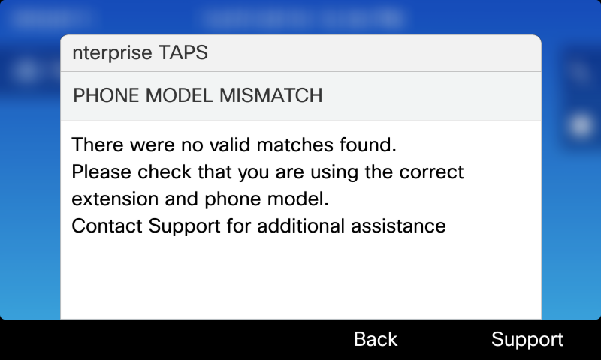
   1. Similarly if there are matches but they don't match the phone model you are connecting from you will see this error.
4. **SELECTION LIST**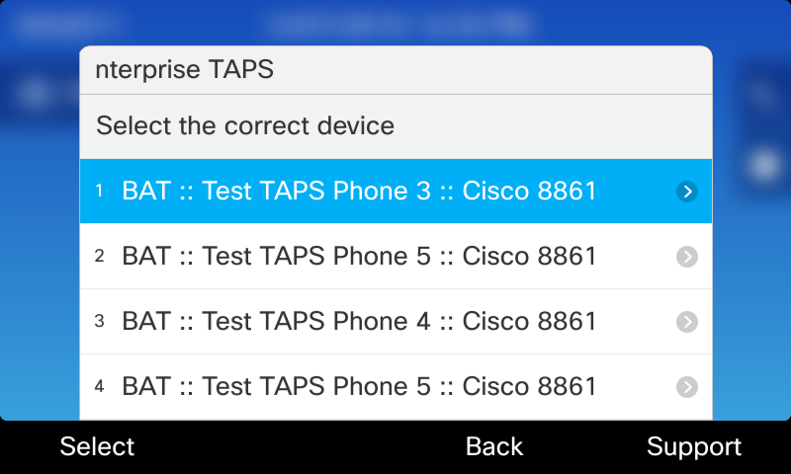
   1. If there is only one match you will skip this screen and configure immediately
   2. You will only see matches that have it as their PRIMARY line – so no dealing with shared line nonsense
   3. If there are multiple matches you will see a list you can choose from with the Type, Description, and Model
   4. There is an optional feature flag to enable also finding SEP devices too, so you could actually use it to convert an existing non BAT phone via TAPS too. But by default it would only display BAT matches
5. **SUCCESS**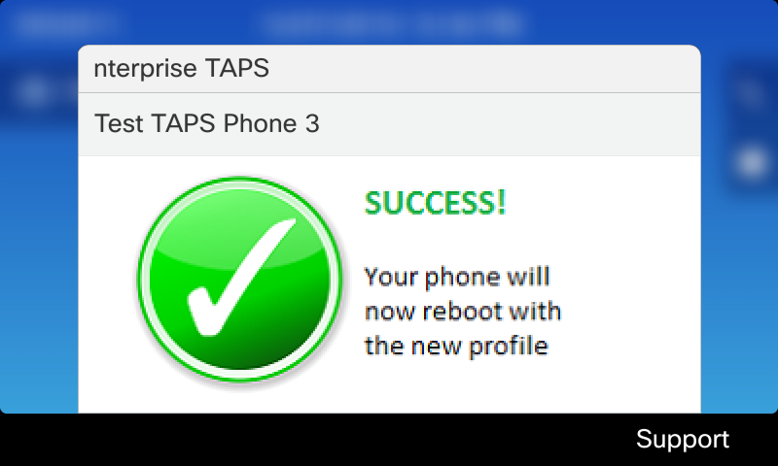
   1. Upon successful configuration your AutoReg phone is deleted and the BAT (or SEP) device chosen is updated with the MAC
   2. Phone reboots
   3. There is also a FAILURE screen if it fails to properly complete the config update:
      1. 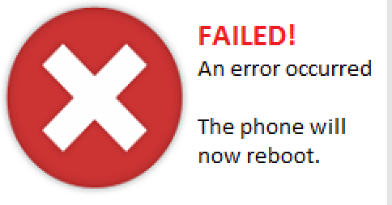
   4. Program does a check for certain models that don't support images and displays a text-only message instead (7800, 6900, etc)
6. **UNDO FEATURE**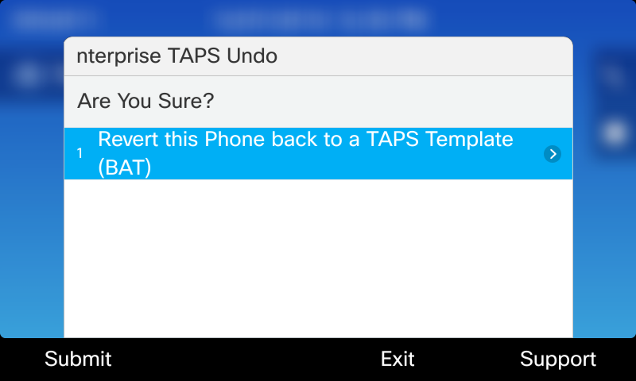
   1. An additional optional phone service can optionally be configured under the services button.
   2. This provides a method to convert the phone BACK into a BAT template
   3. Good for handling deployment mistakes, temporary decommissioning, etc
7. **LOG FILE**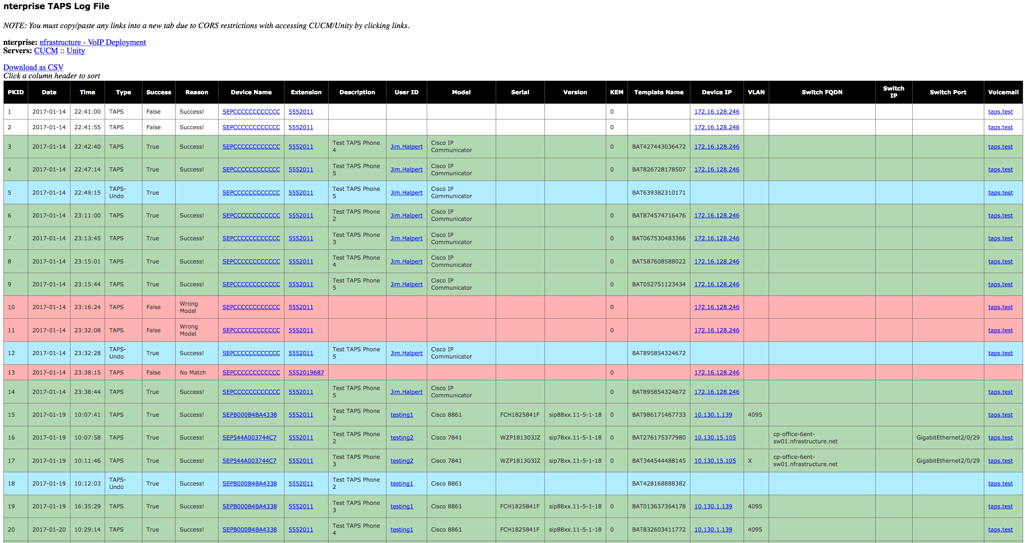
   1. A log is kept of all transactions, flagging any failures and highlighting any “undos”
   2. Page auto-refreshes for live monitoring
   3. It can be downloaded as a CSV via the link
   4. Captures the custom fields
8. **Webex Teams Bot:**
   1. 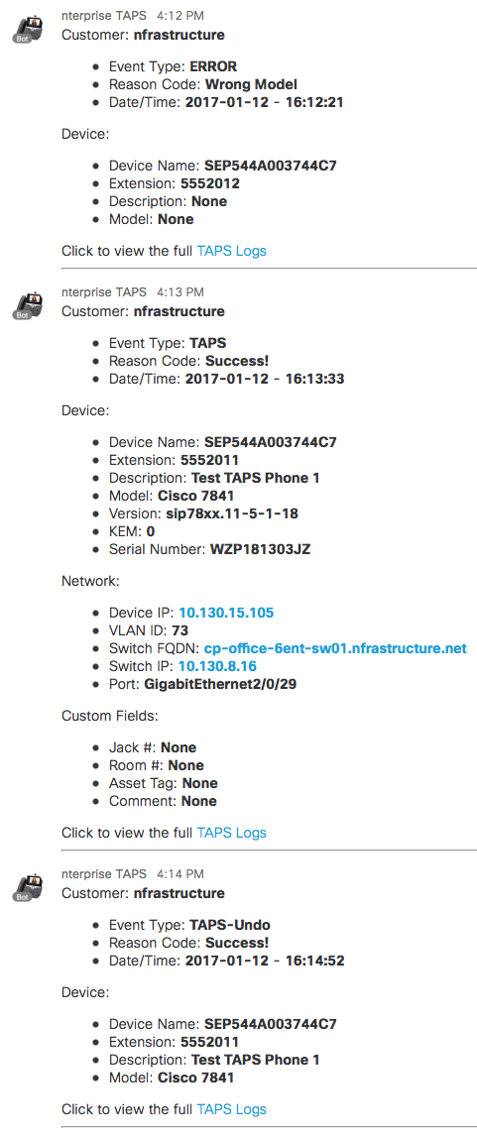
   2. Can be integrated via the “**nterpriseTAPS@sparkbot.io**” bot to automatically post statuses to a Teamspace to monitor live deployment activity
   3. Provides a link to the full log files for quick access
   4. Provides quick URLs to various components for quick access
9. **Interactive Bot:**
   1. Enhancements have been added to allow for an interactive bot. See examples of the available commands and results:
      1. **/hello**
      2. **/help**
      3. **/stats**
      4. **/project**
      5. **/search ####**
   2. 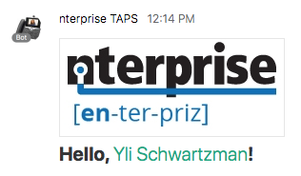
   3. 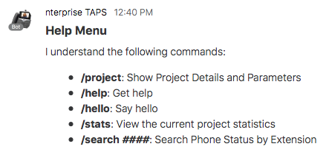
   4. 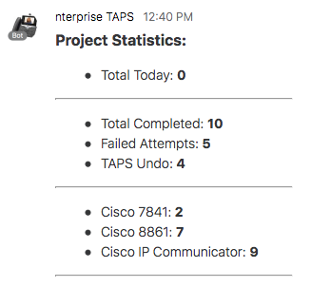
   5. 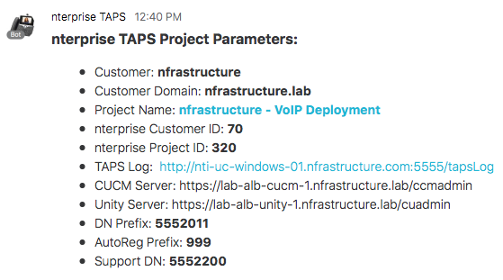
   6. 